Good Design: Starbucks App on Androids

* Purpose
* The purpose of this app is to provide a way for members to quickly pay for products at stores and for them to check on their membership status. The intended users would be anyone wishing to speed up the process of paying at Starbucks.
* Learnability
* The UI for this app is well developed in terms of learnability. Although there are no physical button-like objects, it does not take a long time to learn that pushing the words lead to different pages. The barcode is a simple metaphor showing that users should scan to pay. There are also other extensively used icons in the app such as the three-lined menu icon and the counterclockwise circle for reloading.

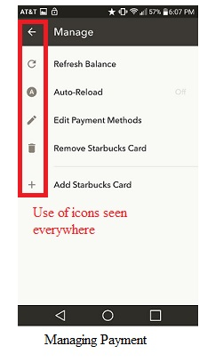 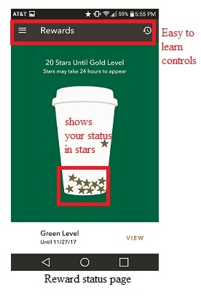

* Efficiency
* The UI in the app has several instances of efficiency. The chunking of market words such as “pay”, “reward status”, etc. gives a sense of where everything is. Also, in terms of keystroke/touchscreen, the app responds very well, loading pages quite quickly. In terms of the real world, a barcode is the only thing that is scanned to speed up the process of payments.

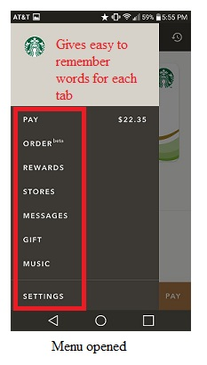 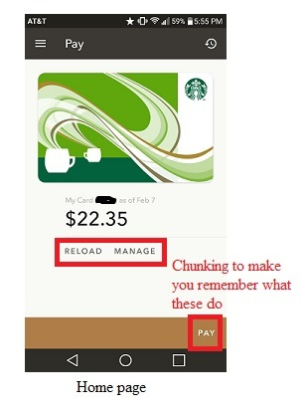

* Safety
* There are components of safety such as not giving away the user’s full card number, but only the last 4 digits and the last time the user reload their balance. It also gives a notification of receipts when the card is used to see if other people are using their accounts.

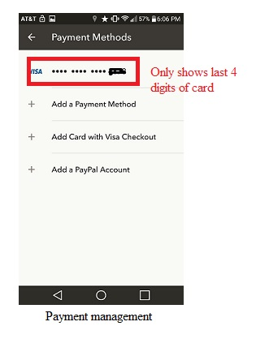 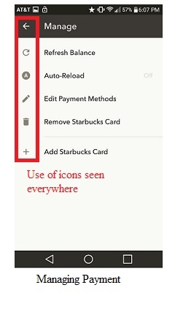

Bad Design: Miss Universe 2015 Nomination Card

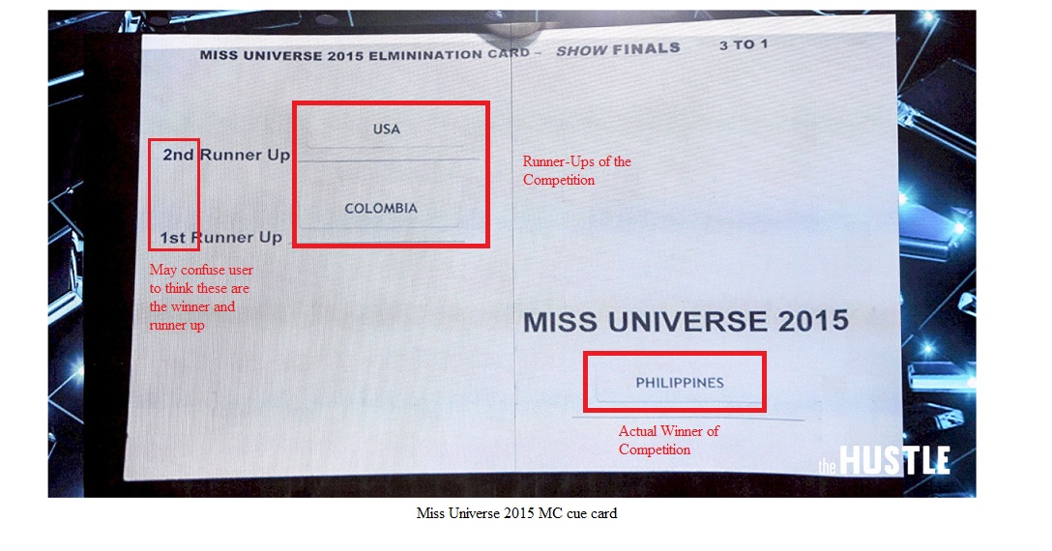

* Purpose
* The purpose of this UI was to inform the MC (Steve Harvey), the intended user, who the winner and the two runner-ups of the competition.
* Learnability
* The layout of the card is set up so the first items that come to the user’s eyes are the names beside the “1st runner-up” and “2nd runner-up”. With knowledge-in-world in mind, MC’s will usually find the winner’s name next to a slot with “1st” next to it, and with knowledge-in-head in mind, when the MC sees the big MISS UNIVERSE 2015 sign, he would think of the words as a cue card title, recalling the competition name. Lastly, the winner’s name is set in a location where the MC could easily miss.
* Efficiency
* In terms of efficiency, we see that we can relate chunking with seeing “1st” to mean the winner and “2nd” to be the runner-up. It would be very common for someone to mix these everyday terms and create a problem. It is also not very efficient to put the two runner-ups in a blatantly easy to read position while the winner’s name is at a hard to find position.
* Safety
* The UI of MC card jeopardizes the chances of the announcer to gather wrong information due to confusion in learnability and efficiency. This confusion ends up in a live broadcast mistake that can cause uproars to certain people.